Rudra Modi

ruraina@microsoft.com

Abstract

Learn how to leverage the Dynamics 365 Health Accelerator Analytics through this Setup Guide

Dynamics 365   
health accelerator - IOT   
ANALYTICS

Microsoft Corporation

Contents

No table of contents entries found.

# Overview

This document outlines the setup guide for lighting up some sample scenarios for Health Accelerator- IOT Analytics. Once the setup is complete, you can use these reports to derive valuable insights on your patient device data.

If you are looking for information on the health accelerator such as the API reference or examples for extending the model, please look [here](https://community.dynamics.com/365/b/healthaccelerator/dashboard).

# Components of the Accelerator

The accelerator consists of several components as shown below. The scope of this document is to outline how MS Teams can be used in context of the HealthCare Accelerator.

* Entity Model: extensions to the Microsoft Common Data Model
* UCI App: Customer Engagement sample UCI App
* Legacy App: Customer Engagement Legacy App
* *Office: MS Teams for Care Team collaboration (also found in the same git repo)
* *PBI Analytics: Templates for patient/clinic insights (also found in the same git repo)
* *IOT PBI Templates: Current scope of document is to share some PBI samples built upon the device data Health Accelerator
* *AI / Azure: We are working on AI / Azure extensions and samples

# Pre-requisites

* Required Roles – Read access on Health entities.
* License - Enable PBI license on your tenant. To check if you are applicable for trial, navigate to <https://powerbi.microsoft.com> and check the trial setup options.

# Setup - Analytics Package

## Import Customizations

Navigate to the github folder and import the ‘IOTCustomizations.zip’ solution into your organization. Publish customizations.

## Import Data into CDM entities

Navigate to your Dynamics application-> Settings -> Data Management -> Imports -> Import Data-> select the files below one by one and follow steps to get the data imported. Sequence of Import –

* 1PatientData.xlsx with Duplicate Detection enabled
* 2DevicesData.xlsx with Duplicate Detection enabled
* 3TemperatureData.xlsx with Duplicate Detection enabled
* 5StepsData.xlsx with Duplicate Detection enabled
* 6HeartBeatData.xlsx with Duplicate Detection enabled
* 7BloodOxygenData.xlsx with Duplicate Detection enabled

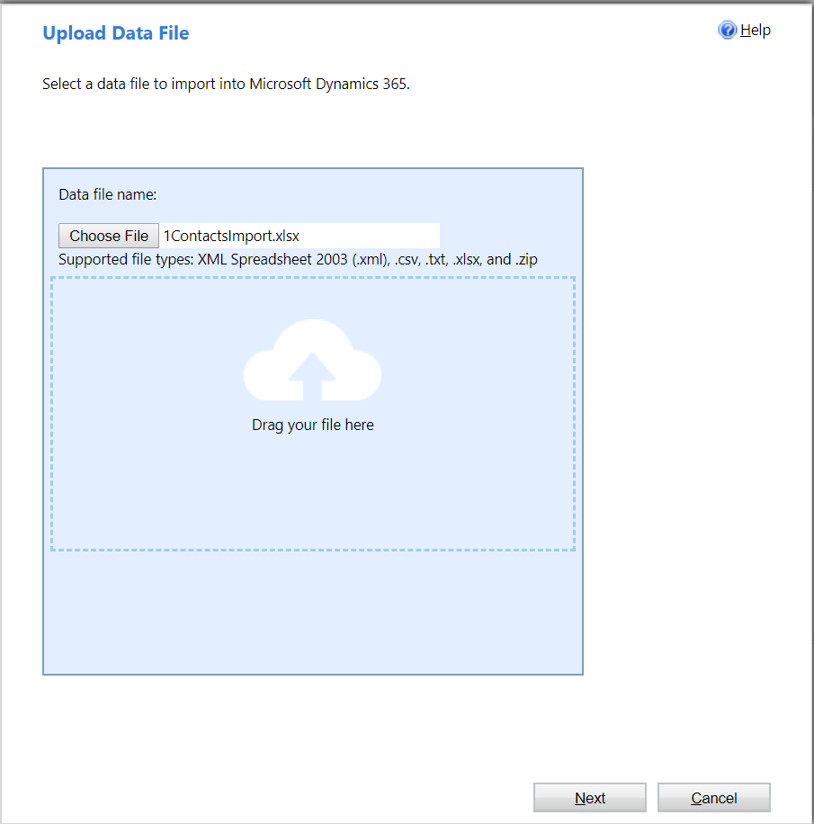

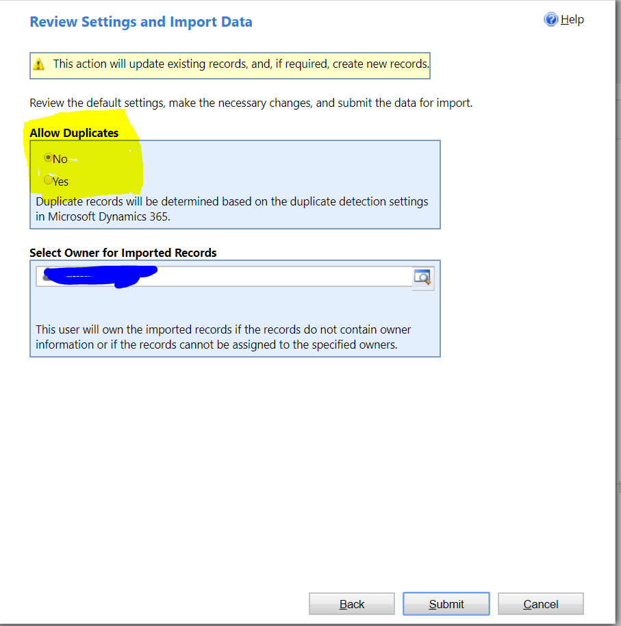

Note that all the data has been imported into the entites – Contacts, Appointments and Encounters

## PBI Package

* Download PBI desktop [here](https://powerbi.microsoft.com/en-us/desktop/)
  + Get the IOT-Analytics.pbit from the repo and
  + Launch Power Desktop and click on File-> Import->Browse to IOT-Analytics.pbit. Click Import.
  + You would be prompted to set parameters in a dialog now. Enter your CDSEndpoint eg:

***https://<<orgname>>.api.crm.dynamics.com***

* + Enter the credentials for the endpoints when prompted.
  + Set privacy levels for your data when prompted.

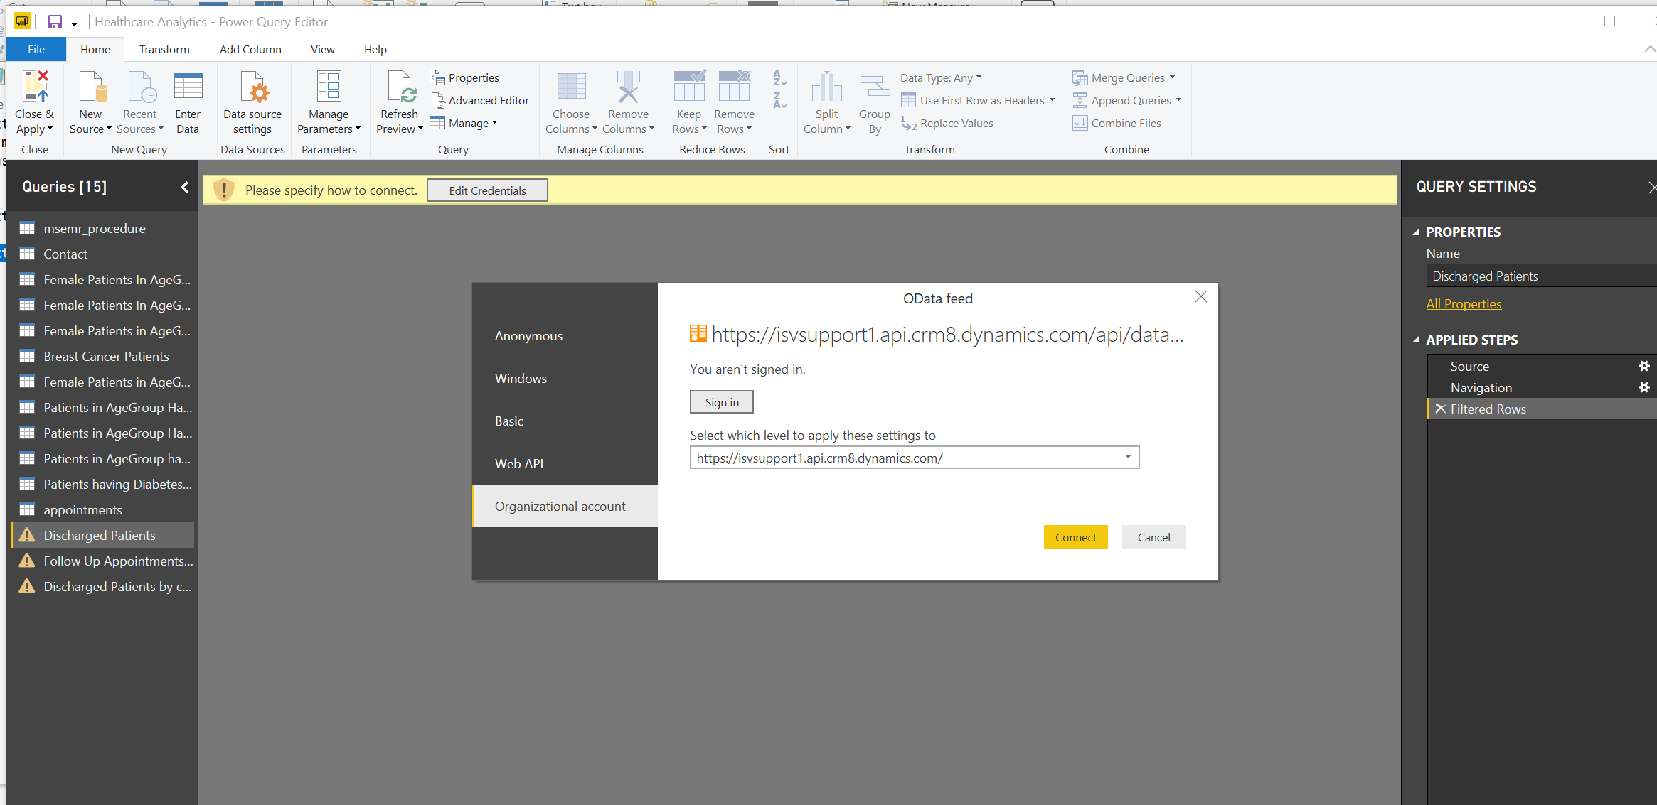

* + You might see a refresh error. Navigate to Edit queries and note the tables load. Click some tables to make sure data load is complete and preview shows up. Close and Apply.
  + Note the reports populate. These are just sample reports to show how healthcare accelerator can be used to light up analytics for device data.

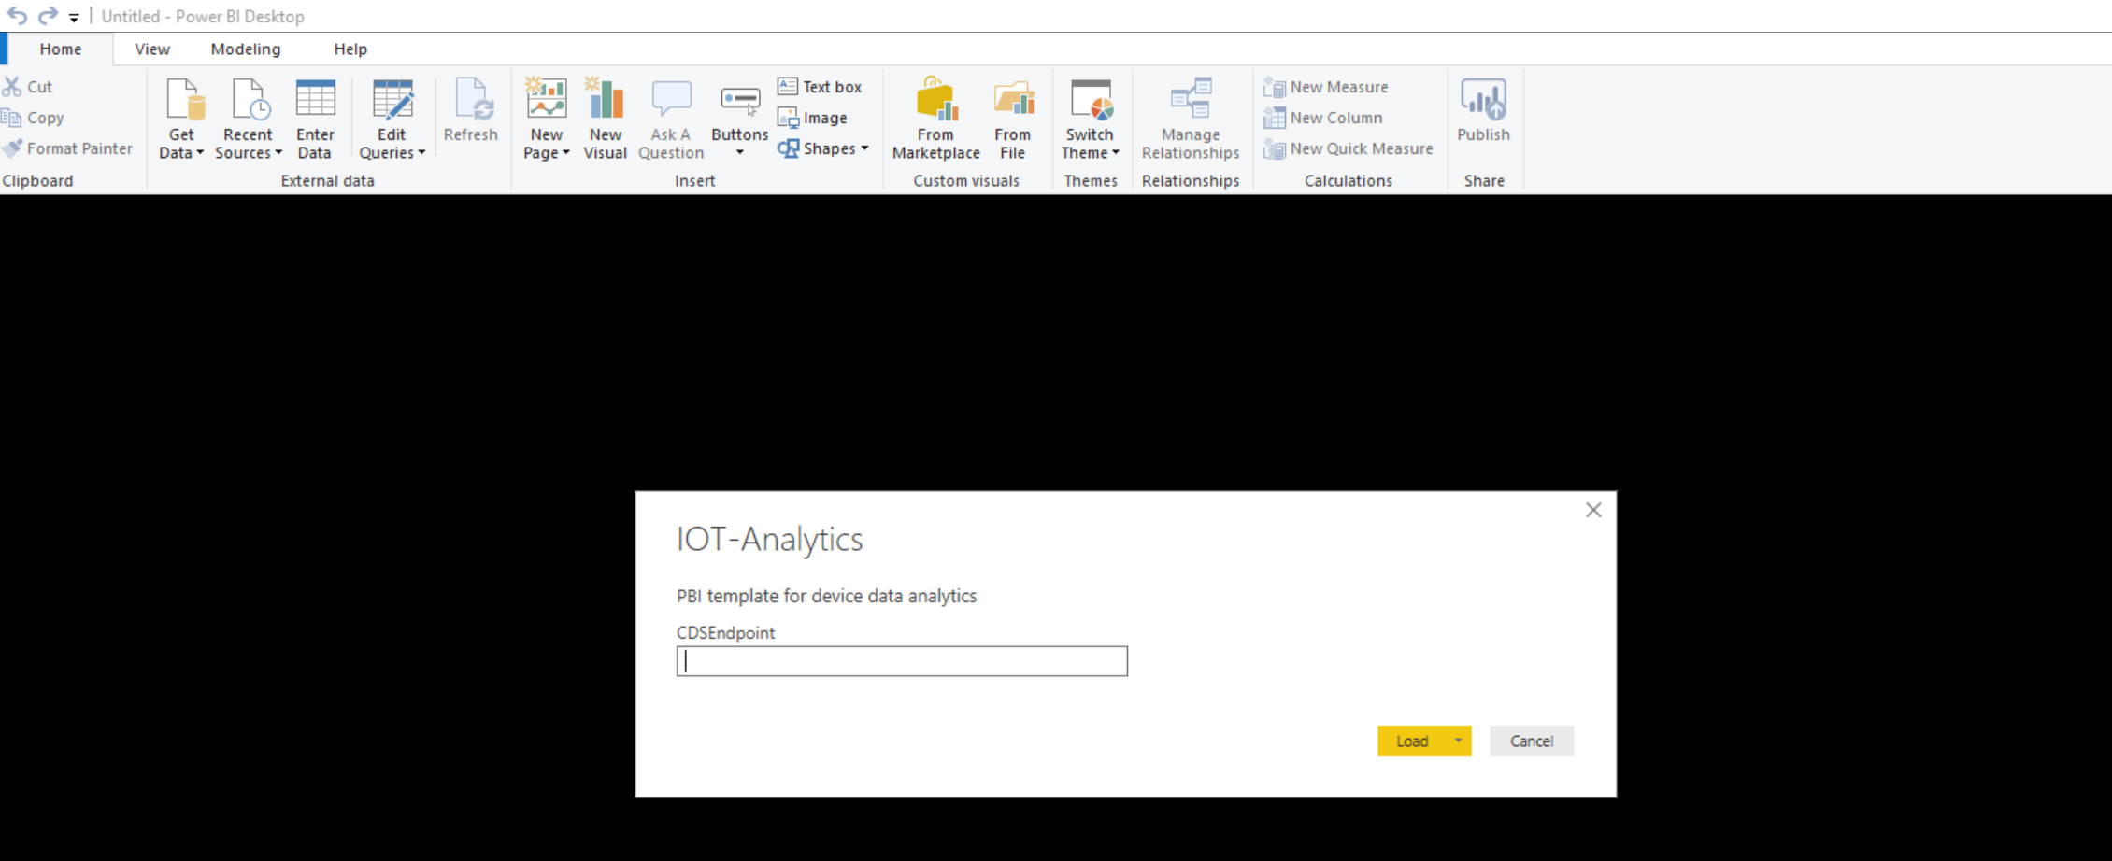

* + Then see the warning sign has removed from all tables. Close and Apply.